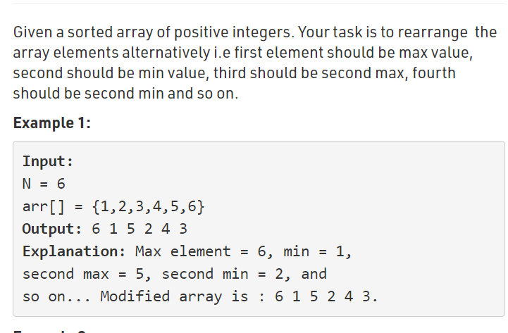

<script>

var n = prompt("Enter the number");

var arr = [];

var a = [];

var s = 0,l = n-1;

for(var i = 0;i<n;i++)

{

arr[i] = prompt("Enter the Number");

}

for(var i = 0;i<n;i++)

{

if(i%2 == 0)

a[i] = arr[l--];

else

a[i] = arr[s++];

document.write(a[i]+" ");

}

</script>